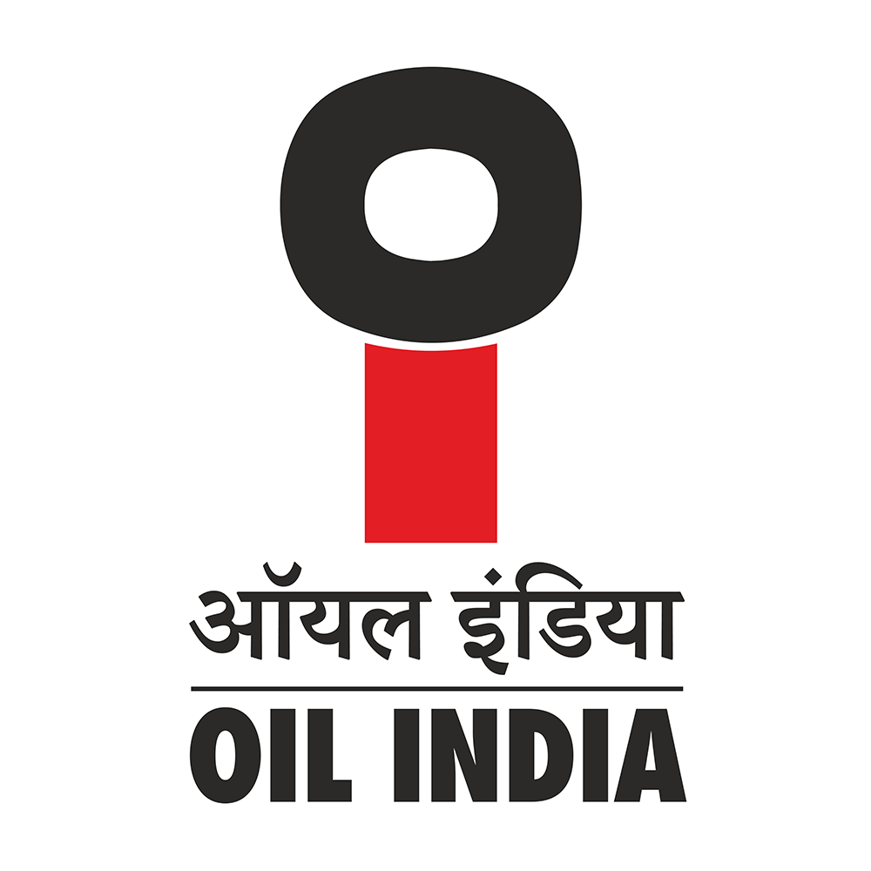
OIL INDIA LIMITED
CORPORATE OFFICE, NOIDA

OIL/PLNG/54/2/1/2026/90 26th March, 2026

Ministry of Petroleum and Natural Gas
Kartavya Bhawan-03, Janpath
New Delhi - 110001
Kind Attn: Ms. Neha Pal
Section Officer (ONG III)

Sub: Rajya Sabha Provisionally Admitted Starred/Unstarred Question D. No. S10326 for
30.03.2026 regarding “Oil and Gas Production and Energy Security”
Ref. Your email dated 19.03.2026
Madam,
Reference above, our reply to the above Rajya Sabha Question is as follows:
Q.(a) Whether Government has conducted any recent assessment of domestic crude oil and natural gas production in the country, if so, the details thereof, particularly in the context of India's growing dependence on energy imports; | Answer to Q(a): MoPNG may reply suitably.  As far as Oil India Limited (OIL) is concerned, the company regularly provides inputs on domestic crude oil and natural gas production to PPAC, DGH, and the Ministry, or as and when required for the regular assessment of Country’s domestic Crude oil & Natural Gas assessment.  OIL is aware of India's growing dependence on energy imports and has been taking multiple steps towards enhancement of domestic crude oil & Natural gas production. The steps being taken to enhance domestic output and reduce import dependence- attached as Annexure-I.
Q.(b) If so, the details thereof, including the production levels of crude oil and natural gas, during the last three years; | Answer to Q(b): MoPNG may reply suitably.  As far as Oil India Limited (OIL) is concerned, the domestic crude oil and natural gas production during the last three years are provide below:  Parameters UoM 2022-23 2023-24 2024-25  Crude oil MMT 3.18 3.36 3.46  Natural Gas MMSCM 3.18 3.18 3.25
Q.(c) Whether Government has taken any steps to ensure a steady import of oil from foreign countries amidst rising war tensions in the West; and | Answer to Q(c)&(d) : MoPNG may reply suitably.  As far as Oil India Limited (OIL) is concerned, OIL has not been importing oil from foreign countries. Hence, no response to offer in this regard.
Q.(d) If so, the details thereof?

Yours faithfully,
OIL INDIA LIMITED

-SD-

(Ashim Kr. Bharali)
General Manager (Planning)
For Chief General Manager (Planning)
For Chairman & Managing Director

Encl: Annexure-I

OIL/PLNG/54/2/1/2026/90 26th March, 2026

Annexure-I

Steps being taken to enhance domestic output and reduce import dependence

As far as Oil India Limited (OIL) is concerned, OIL has been aggressively taking up the exploration and production activities along with substantial investment in alternate energy sectors in line with the GoI initiatives to reduce India’s dependence on imports.
OIL has achieved a quantum jump in its acreages after the implementation of HELP and presently holds 93,052 sq. km acreages across various regimes divided into 63 blocks across the nation including offshore blocks.

OIL is currently carrying out domestic E&P activities in a total of 63 nos. of operated acreages. These include 25 nomination Petroleum Mining Leases (21 in Assam, 2 in Arunachal Pradesh and 2 in Rajasthan), 1 Nomination Petroleum Exploration License (PEL) in Arunachal Pradesh, 2 NELP Blocks in Assam, 32 OALP Blocks (12 in Assam & AP, 1 in Nagaland, 1 in Meghalaya, 3 in Tripura, 3 in Rajasthan, 1 in Gujarat, 4 in Mahanadi & 2 in Mahanadi Ultradeep Offshore, 2 in Andaman shallow offshore, 1 in Kerala Konkan shallow offshore, 2 in KG Ultradeep Offshore) and 3 Discovered Small field (DSF) Blocks (1 each in Tripura, Rajasthan and in KG Shallow Offshore). The total operating acreages cover an area of 93052 sq.km. Apart from this, there is a non-operating acreage to the tune of 14,776 sq.km spread across 7 blocks. As of 28th Feb,2026, OIL drilled 17 wells in OALP blocks including 2 offshore wells and established the presence of hydrocarbon in three blocks.
To drive future growth and enhance production, OIL’s key endeavours can be broadly summarized as follows:
- Enhancing Production: One of OIL’s major visions for the coming years is to increase production from the current level of 3 MMT to over 4 MMT. To achieve this, OIL has planned extensive field development activities in its nominated blocks, 32 active Open Acreage Licensing Policy (OALP) blocks covering 92,888 sq.km, and three Discovered Small Fields (DSF) spanning 208 sq. km. These efforts aim to intensify exploration and development programs across the country.
- Accelerated Exploration and Redevelopment: OIL is fast-tracking exploration and redevelopment activities, including fields in Arunachal Pradesh. Recently, the company successfully acquired 51,555 sq. km of exploration acreage, including 10,965 sq. km in collaboration with ONGC. Additionally, OIL achieved a significant milestone by drilling 57 wells in FY 2024-25 and taking steps to increase the wells drilled in FY25-26.
- Focused Development Areas: The company has identified several key areas for fast-track development, which are expected to substantially enhance production levels in the near future.
- Advanced Recovery Techniques: To maximize recovery from its mature fields in the Upper Assam Basin, OIL continues to implement water injection techniques and other IOR (Improved Oil Recovery) and EOR (Enhanced Oil Recovery) technologies.
- Adopting Innovative Technologies: OIL is actively deploying fit-for-purpose technologies to improve production efficiency and optimize operations.
- Collaborative Efforts: OIL is collaborating with national and international institutions and industry leaders to leverage expertise and resources for enhanced exploration and production activities.

In addition to these initiatives, OIL is implementing a comprehensive strategy comprising short-, mid-, and long-term measures for enhancement of crude oil production as detailed below:
• Short-term Measures: These include well intervention activities and the immediate induction of new technologies to address operational challenges.
• Mid-term Measures: Creation of surface facilities to remove bottlenecks and facilitate smoother production processes.
• Long-term Measures: Maximizing recovery from mature fields through advanced IOR/EOR techniques.

Apart from the conventional sources of energy OIL is in the process of establishing 25 Compressed Biogas (CBG) plants across India, utilizing Municipal Solid Waste (MSW), agricultural waste etc. as feedstock. The CBG plants at Tinsukia (Assam) and Bhubaneswar (Odisha) are currently under construction and are expected to be completed by 2027. Additionally, tenders for Jorhat (Assam), Cuttack (Odisha), and Agartala (Tripura) have been floated whereas the remaining 20 plants are at various stages of development. OIL is also establishing 645 MW of solar power generation through JV with Assam Power Generation Corporation Limited (APGCL).
OIL is presently being Green Hydrogen (2%) with natural gas at India’s first AEM-based GH₂ pilot plant (30 kg/day) Jorhat. A 1 MW GH₂ plant (400 kg/day) is under construction at Nalagarh, Himachal Pradesh, in collaboration with Himachal Pradesh Power Corporation Ltd

OIL’s material subsidiary NRL’s 50 KTPA 2G bioethonal plant has been inaugurated by the Prime Minister on 14th Sep 2025 which uses bamboo feedstock. Moreover the 2.4 KTPA Green Hydrogen plant is under commissioning phase.
Government has taken various initiatives and actions in the recent past to facilitate domestic exploration and production of petroleum and natural gas. Some of the major initiatives are stated below.
- Hydrocarbon Exploration Licensing policy (HELP) & Discovery Small Fields (DSF)
- National Seismic Programme (NSP) and Deep Andaman offshore Surveys
- Airborne Gravity Gradiometry and Gravity-Magnetic survey
- Drilling of Stratigraphic Wells
- Seismic Campaign Under Mission Anveshan (MA) & ECS beyond EEZ
- Opening of No-Go Areas for E&P Activities.

Details of the major initiatives taken by Government of India are stated below.

(i) Hydrocarbon Exploration Licensing policy (HELP) & Discovery Small Fields (DSF): The Hydrocarbon Exploration Licensing policy (HELP) was launched by GoI in March 2016 to domestically fast track exploration activities through Open Acreage Licensing policy. Similarly, Govt. of India introduced the Discovery Small Fields (DSF) with the objective to bring the unmonetized discovery of the country into production.

OIL has actively participated in all recent bid rounds of Open Acreage Licensing Policy (OALP) and Discovered Small Fields (DSF) under Hydrocarbon Exploration Licensing Policy (HELP) and has significantly increased its domestic acreages. Presently, OIL has 32 nos. of OALP Blocks (Northeast-17, Rajasthan-3, Odisha-4, Gujarat-1, Andaman shallow offshore-2, Kerela Konkan shallow offshore-1, Mahanadi Ultradeep-2 & KG Ultradeep-2) covering 87,432 sq.km and 3 nos. of DSF Blocks covering 208 sq.km across eight sedimentary basins. So far, OIL has completed drilling of 19 nos. of exploratory wells (5 in Rajasthan, 6 in Odisha, 6 in Assam and 2 in Andaman) in 13 (Thirteen) OALP blocks which includes two shallow offshore exploratory well in Andaman Basin. During 2024-25, OIL has established the presence of hydrocarbon in two OALP blocks in Assam, out of which One discovery has been monetised. Further drilling and exploration activities are ongoing at full scale in the other OALP blocks also. Till date, OIL has completed 6 DSF wells (4 in Rajasthan & 2 in Tripura) and NG production has brought into stream from 3 wells in Rajasthan DSF block. Further drilling in DSF Blocks is going on.

(ii) National Seismic Programme (NSP) and Deep Andaman offshore Surveys: Ministry of Petroleum and Natural Gas (MoP&NG) and DGH had taken an initiative to cover the Un-appraised area of the country with 2D Seismic Survey both onshore through National Seismic Programme (NSP) and Deep Andaman offshore. As entrusted by DGH/MoP&NG, OIL has completed 5245.80 LKM and 22554.60 LKM of 2D Seismic Surveys under the National Seismic Programme (NSP) on May 2022 and Deep Andaman Offshore on March 2023 respectively.

(iii) Airborne Gravity Gradiometry and Gravity-Magnetic survey: To cover areas where seismic data couldn’t be acquired under National Seismic Programme (NSP) due to inaccessible terrain and hostile environment, GoI formulated a planned to conduct Airborne Geophysical survey to acquire 49,795 flight LKM Gravity Gradiometry and Gravity-Magnetic data. Accordingly, OIL was entrusted by MoP&NG and DGH to execute Acquisition, Processing & Interpretation (API) of Airborne Gravity Gradiometry & Gravity Magnetic (AGG & GM) studies. The areas cover Spiti in Himachal Pradesh & Ladakh, Jhanskar-Karewa in Jammu & Kashmir UT, Bastar in Chhattisgarh & Odisha, Cauvery Basin in Tamil Nadu, and parts of Northeast (Assam, Arunachal Pradesh, Nagaland, Manipur, Meghalaya, Mizoram & Tripura) India. The AGG & GM survey commenced on 27.05.2023 concluded on 15.02.2024. A total of 42,943.09 flight LKM of data was recorded. The project was completed on 31.03.2024.

(iv) Drilling of Stratigraphic Wells: Under the GoI initiative, OIL is working along with ONGC to drill four stratigraphic wells in Mahanadi, Andaman, Bengal Purnea and Saurashtra Basins to acquire crucial geoscientific data for expediting efforts in making oil and gas discovery in the unexplored offshore frontier regions.

(v) Seismic Campaign Under Mission Anveshan (MA) & Extended Continental Shelf Project (ECS) beyond EEZ: The Mission Anveshan (MA) & appraisal of Extended Continental Shelf (ECS) beyond Exclusive Economic Zone (EEZ) of India is a flagship initiative of the Government of India under the aegis of the Ministry of Petroleum and Natural Gas (MoP&NG). Mission Anveshan (MA) is a sequel to the National Seismic Program wherein 2D Seismic API was carried across different on land sedimentary basins of the country.
Under MA program, MoP&NG has instructed OIL & ONGCL to carryout 2D Seismic Acquisition, Processing & Interpretation (API) of 20,275 LKM in the on land Indian Sedimentary basins. Under ECS Project, MoP&NG has instructed OIL & ONGCL to carryout 2D Seismic Acquisition, Processing & Interpretation (API) of total quantum of 30,000 LKM for the appraisal of ECS beyond EEZ in the eastern and western Offshore India.

Out of the total allocated project quantum of 20,275 LKM 2D seismic API, OIL has been entrusted to carry out a total of 9,400 LKM out of total 20,275 of 2D seismic survey in areas of Rajasthan (4300 LKM) and Ganga-Punjab (5100 LKM) Basins. The survey commenced on 28.10.2024 and is currently under progress. Oil & Natural Gas Corporation (ONGC) has been entrusted with the remaining quantum of 10,875 LKM covering Krishna-Godavari, Chhattisgarh and Cuddapah Basins. As on 23.03.2026, the total surface coverage in Rajasthan basin is 3795.56 LKM and in Ganga- Punjab Basin is 4582.44 LKM. The cumulative surface coverage of the Project under OIL is 8378 LKM (89.13%).

Similarly, out of the total allocated project quantum of 30,000 LKM offshore 2D seismic API, Oil India limited (OIL) entrusted to carry out 14,500 LKM 2D seismic API in ECS of Eastern offshore and the remaining 15,500 LKM to be carried out by ONGCL in the Western offshore. The acquisition operation commenced by OIL on 04.02.2025 and completed on 13.06.2025 after the acquisition of 14513 LKM. OIL successfully completed the 2D seismic API on 13th January 2026.

(vi) Opening of No-Go Areas for E&P Activities: Recently, GoI has significantly reduced the earlier "No-Go" areas by around 98% and this also includes 99% of area earlier prohibited for security reasons in India's Exclusive Economic Zone (EEZ). The total exempted area from No-Go restriction is around 1 million Sq. Km.
The opening up of over 1 million Sq. Km of area will allow the E&P operators to stretch their exploration campaign to a much larger area which includes a significant area under EEZ. Exploration activities in the newly opened up frontiers of deep & ultra deep offshore of the country is being highly encouraged by the Government thereby creating opportunities of making new discoveries and increasing domestic oil and gas production. The government expects significant increase of capex by the oil companies in the forthcoming years on account of opening of No-Go areas and other policy initiatives like OALP, DSF etc.
Oil India Limited also views this as a significant opportunity and intends to acquire exploration acreages through forthcoming OALP Bid Rounds in these newly opened-up areas.

****

